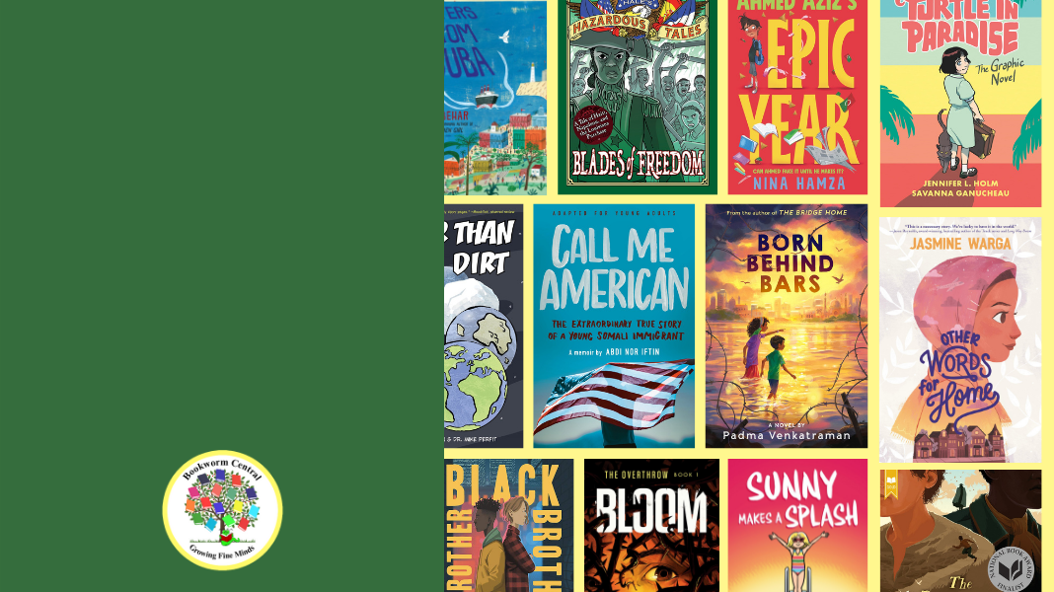

[Insert School Name]

Our

Online Bookstore is OPEN!

[Insert Link]